GDE ICA: GAME DESIGN BRIEF
THOMAS HILL
Computer Games Programming
B2020437

Title:
Pigeons Vs Seagulls

Players:
1-4

Platform:
Consoles
Game Design Document
Games Description

Being ten years old and living in Erstwhile city is a hard task. Ten year olds love playing in the park but it’s overrun by an infestation of Pigeons and Seagulls. Both have set up nests in the park, and have made it completely unusable.

The park is a state, covered in a dull grey, and with bird mess everywhere, all the local children are scared to even set foot out of their house, let alone go down to the park. Parents just blame the council, and the council are nowhere to be seen. Enter: The player.

Armed with the pack-lunch their Mum gave them that morning, they are to set out to find a way to get rid of the birds. They’ve got to be moved away, but how? They only seem to do anything, if they’re scared or if there’s food around.

There’s no way that the birds can be killed. So, the only choice is to move them on. Taking an area of the park, one step at a time, the player must move them into the next area of the park. How they do this is up to them of course. Two options exist; literally scaring or leading them with crumbs to the next area (via an exit), or you could lead them to each other and learn just how much the two species of birds hate each other.

Leading a pack of each bird into one another will mean that they have to meet, and when they meet they’ll then fight. Fighting consists of the birds flying into each other in what seems a chaos of swarming birds, and a flurry of flying feathers.

An even fight, due to the differing sizes of the two birds, will mean that the pigeons would outnumber the seagulls two to one. When there is an even fight, it means eventually the birds will both start to lose the battle, and when they eventually weaken themselves, they’ll fly away in terror. Flying conveniently to the next area.

Once the area is free of birds, you must go to the next area of the park. Here, you’ll find one of two things; either the flock of birds has descended upon this area, and they’ll be neatly all arranged in a group, and all you’ll have to do is round up the others that were already here to join that group; or you’ll find that because you scared the birds one by one into this area, they’ll all be split up and in random spots across the area. [See Appendix One for a diagram of these bird movements]

Having all the birds neatly arranged into groups of their species means that you’ll be able to manage moving the birds easier. For example, if you wanted to move them all to the next area, you could treat the whole flock as one entity, and scare/coax the whole group. It’s also essential to have them as a group if you want to pit the two against one another, as that way the highest number of birds will fight and scare each other away.

Moving a bird into the next area will earn you a specific amount of points, however getting a bird to fly away to another area will give you double these points. Therefore making the birds meet each other and fight will not only make future progress easier, but will also give a greater benefit points wise.

Each area of a level will have a perfect ratio of pigeons to seagulls, so that if the player were to round them all up and make the two meet they would fight each other off perfectly. Each area begins like this, so that if the player plays through the game ‘perfectly’ then every single bird will fly away from the current area.

If the player doesn’t round them all up perfectly, or scares some of the birds off to the next area ‘one by one’ before rounding them up, then there will be some birds left over from the outnumbering of the two groups in the fight. The player will have to move these birds to the area exit, so that the area will be free of birds. Overall, there are three ways to finish a level, ‘herd’ them to the next area, round them all up and then make them fight, or a mixture of the two.

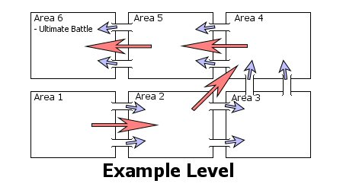
Levels will be made up of a number of areas, which are all connected to one another. In each area there will be two ‘exits’, one for the Pigeons, and one for the Seagulls. These exits will lead to the next area for each bird. Once the player has got through to the last area, all of the birds from previous areas should be in this place, and the player will be required for to scare off the birds for good. In this last area the player will be required to pitch the two types of birds together in a fight, even if they have used the herding technique throughout the other areas in the level.

Red arrows show the movement of birds when flying between areas.
Blue arrows show the individual herding of birds through the areas.
Note: Birds flying could mean that they miss out certain areas.

This game play, in general could get boring quite quickly if there is no other challenge other than finding the birds, and rounding them up. Therefore, obstacles are injected into the mix in the different areas. For example, a ‘mad old woman’ could be on the side of the park, appearing everything minute where she then spreads bird seed. Being tastier than your bread crumbs, any birds nearby will be instantly drawn to it. If the player has any birds positioned near this old woman, they’ll lose them to her, and they’ll then have to wait until all the food has been eaten before they can try to coax the birds back.

Other examples include the fact that you can’t spread bread crumbs on a river or pond, so you’ll have to travel around them. Teenagers with BB guns, who although firing at the birds, and scaring them to the next area could scupper your plans of an even fight too.

Perhaps you’ll have to lead the birds over a road? You could coax them through a badger tunnel under the road, or maybe you’ll risk your life and stand in the middle of the road, acting as a lollipop man. When the levels get more urbanised, features such as fountains, and shop signs could be places that the birds will naturally flock back to perch on if left alone for a certain time period, resetting any work you’d just put into moving them through the area, while also adding a sense of urgency to the game.

Other obstacles (or perhaps ‘cheats’) would be the odd occurrence of racing pigeons or wild flocks of birds flying over the area. If they travel near enough to a bird, the bird may be attracted to the flying flock, and just leave the level for good. They won’t be in proceeding areas; they’ll have just left the whole playing level. This accomplishes your job, but because the bird has done it of their own accord you’ll receive no points.

Although the player has an unlimited amount of bread crumbs to spread, they could get new items to use, such as the aforementioned teenagers’ BB gun, or the mad old woman’s bird seed. Maybe you’ll pick up a portable stereo, and scare the birds off with the sound it makes. Other ideas for items are a fisherman’s harmonica, which when used acts like the Pied Piper of Hamilton’s flute, but on the seagulls. For the pigeons, a similar item could be a scale model of nelson’s column held up in the air; all the pigeons that could see it would flock to it. These new items would all have a weakness associated with them, to stop the unbalancing of the game, either being ammunition related, or the more times its used, the more the birds become invulnerable to it.

After the final area in a level has been completed, the player will have cleared the whole area of birds. Taking their score into account, they should be able to play a mini-game (a higher score would mean longer to play). The point of playing the mini-game would be to score as much as possible, to them use this to buy items for the next level. This will reward better players, by giving them a physical item for playing well, and will increase replay value.

Once this level is complete, there will be a number of other levels all set within Erstwhile city. An example of the potential city landscape is below. Levels would be different areas of the city, like the small park, or block of flats. Each would have their own characteristics and potential pitfalls for the player.

To drive the player onward, there will be a story which involves the player going through the different areas of the city as they grow up. Then as they get older and start to hang out in ‘older’ places, they’ll have the same problem as before - the birds are getting in the way of them having fun. So the player will get a sense that the birds are following them around the city as they grow up. Eventually this will lead to the player being old enough now, that they have their own children who the infestation of birds will get in the way of their fun. These areas would be the block of flats and seaside, as the player’s character will have moved out of home to the flats, and go on a day out to the seaside. Leading to the very end level, where the player will have to banish the birds for good - by sending them towards the neighbouring city. Also as time goes on, the later levels will have larger number of birds, as a result of them naturally breeding.

Modes of play could be incorporated with the main game for multiple players. A cooperative mode would be very easy to incorporate; where two to four players could work together to get the birds rounded up, or herded to the next level. A multiplayer ‘battle’ mode could be interesting and would probably play very much like a traditional Real Time Strategy game, except quicker. Players could choose to fight as Seagulls or Pigeons, and then have to race and round up all of their chosen birds. Once having rounded up a sizeable force, they’ll then have to lead these birds around the park, and using their group outnumber the opposing birds they come across to then scare all of the other player’s birds away. The object of this game would be to claim the whole area for the player’s chosen bird.

So what would Pigeons Vs Seagulls look like then?
A simple, but grounded in reality look would be preferred for this title. By this, it would not need to be photorealistic, but would need to have functional graphics. The biggest image that needs to be conveyed is when the birds meet and fight one another. Here they must flock, and fly creating an image as if chaos is happening. Feathers will fall to the ground, and the area will look darker, because of the massive ball of fighting birds in the sky.

The camera itself will be set at an isometric viewpoint, which could be rotated, allowing optimum view of the play area.

Also of importance is the look of the individual areas themselves. As many birds inhabit the area, they must look grey, dirty, filled with bird droppings, and decaying feathers etc. As the number of birds in an area decreases, the area’s true colours will come through, and it will look cleaner as a result. For example, as the playground’s bird population is scared away, it will become greener, and the swings, slides etc will go back to their naturally bright colours.

But how would Pigeons Vs Seagulls sound though?
The biggest concern of the game would be to get the sound of the different birds right. It must absolutely contain the squawks and everyday sounds of each bird. The sound of a seagull is very unique for example. The overall aim is to remind the bird of what day to day experience they will have had of the two birds. It must conger up memories of being poo-ed on, flew over etc. by the birds.

Also in league with the look of the areas, the sounds must take the same transition described. When the birds have infested the area, the sounds must be grim, and dirty, but when the area is loosing its bird infestation, there must be more colourful sounds suited to the area that is currently being played in. A playground would be fun, party music, but an industrial estate would have machine based music, but upbeat to signify the happiness of the birds leaving.

And how would Pigeons Vs Seagulls play?
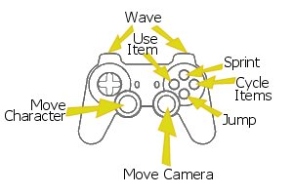
The major game play has already been described, but control-wise the controls would happen much like this. Designed for consoles, both analogue control sticks would be used. The left stick would be for movement around the area, while the right would be to control the camera, by zooming in or out.

Pressing the main action button on the controller will make the character jump, while pressing the secondary action button will make the character use the current item. Items can be switched between by using the right most action button, and the player could sprint by holding the top most action button.

The L and R buttons make the character wave to the left or right accordingly. This helps with herding of the birds, to get them to go a specific direction.

All that’s good, but why’s it fun?
Quick run down: - You’ll finally be able to get your own back on the birds that’ll have at one point annoyed you.
- It mixes the puzzle genre with a 3D adventure.
- It’s cool to set up a fight, and see the chain of events
that a fight entails.
- It encourages the player to play intelligently, giving a
sense of accomplishment and therefore fun.
- Multiple ways for birds through levels, mean players can
play how they want, feeling more in control.
- The multiplayer mode will be unique, but also
competitive, frantic and a test of minds that have can
be absent in other games.
Game Rationale - Make this Game Now!
Herding animals is one of man’s most ancient of pastimes, but yet it has still yet to be successfully translated to a videogame. There is a need in videogames at the minute to come up with new fresh ideas, perhaps herding is one of these? Also missing within videogames these days are games that test the mind. There seems to be many who would like a game that made them think.

There also seems to be many who hate pigeons and seagulls, or even both. Taking all of these ideas, this game is certain to find an audience within the UK. However, as these birds exist in many places across Europe it would also find an audience here.

North America too would find an interest in the game, and so this game could be marketed in these two regions. If the birds didn’t exist in a region, it would be relatively simple to swap them for another bird that did, as there are always some sort of birds that is labelled a ‘pest’ in every region. Doing so would required, some switching of artwork assets, sound effects and a little of the game play.
If localising such as this wasn’t perceived to be the best way, it could simply be labelled as a ‘British thing’ and could sell in this way, ‘foreign and interesting’.

Which ever way was picked, the game could see the start of a new franchise, as people would love to see which animal would be better out of a fight between the two. The franchise could go around the world, lions vs. tigers, wolves vs. bears, rats vs. mice, the possibility is there, and overall for a simple game, that will required smaller resources than most, it’s a risk worth taking.
Example Game Box

Research
Supporting research while making this brief is as follows;

Appendix Two
www.police-law.co.uk Found information on the law of Cockfighting. Found that the game as long as not depicting any hurt to the animals or death would be fine. Therefore the rule of not killing the birds came into play, and the whole game mechanic of herding the birds around a level.
Appendix Three
www.northlan.co.uk/living+here/public+health/pest+control/
Found out much about how Pigeons and Seagulls live. Gave very important information about roosting areas of the two birds. This would be very useful for level design, as the birds will be placed in believable areas in the areas.
Appendix Four
www.bbc.co.uk/1/hi/uk/2097681.stm
An excellent story of gulls, and their attack patterns. Although focusing on the biggest type of seagull, and thus painting a rather worse picture when pitted for a fight against a pigeon. It was found that killing seagulls, or disturbing their nests is actually illegal, and so this together with the ‘police-law’ research meant that killing either bird was definitely out of play.
Appendix Five
Size comparison picture provided by Mike Holton.

This at first was used as a question as to how the game mechanics would work. However, after seeing one single pigeon would never be a match for a single seagull from their size comparison, it was decided to evenly match them, and therefore make an even fight include two pigeons to one seagull. This is evident in the game description.

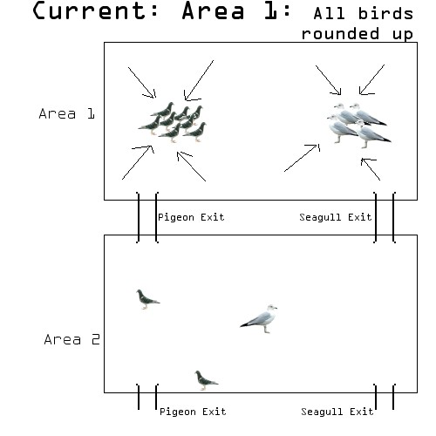
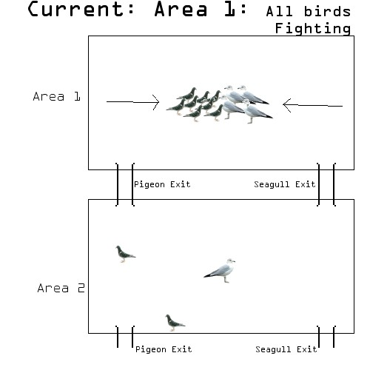
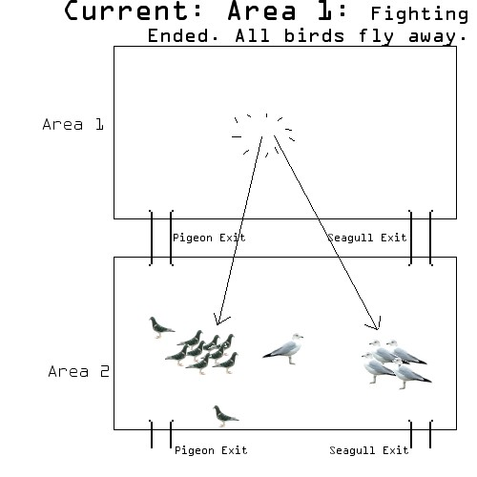
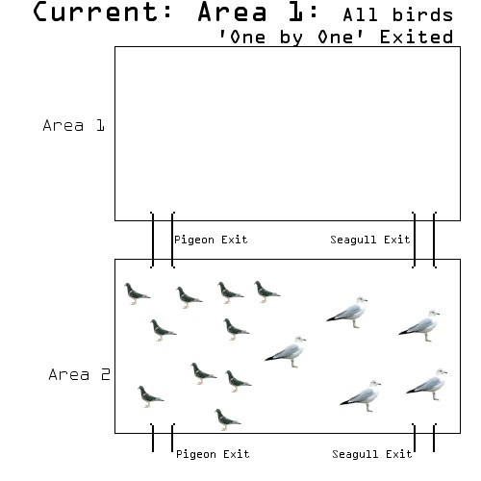
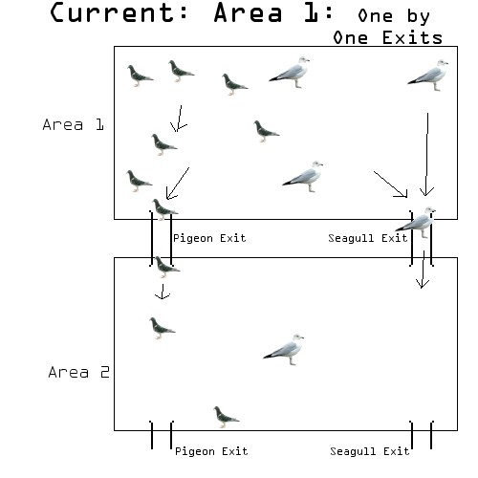
And the loop then continues but for Area 2. This loop carries on for the whole level.
Diagram to show how birds are moved throughout the level, through its areas.
The two methods can be mixed at anytime. The ‘round up’ method is more beneficial because it gives more points to the player, and makes things easier later on. (The majority of birds will all be in one place in later areas therefore easier to manage).
Appendix One:

